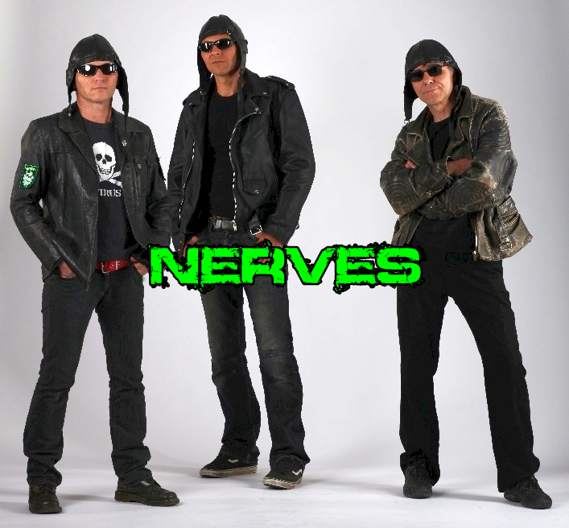
THE NERVES cross melodic pop punk with old school punk rock.

The German band, founded in 1987, with its members CPT. Proton (v,g), ADM. Jack (v,b) and CMDR. Bossi (dr), recently released their 10th album ‘Evolution’.
The 3-man combo plays catchy melodies in a powerful way. Live, everything melts into a party mood, singing along and dancing is guaranteed.

THE NERVES were always a very unique species within the punk rock universe, not easily assimilable, but always weird, wonderful and nice to hear.
Countless shows over the years reflect their permanent metamorphosis, the eternal pursuit of the perfect composition.

Contact: Mail: booking@cptproton.com
Internet: nerves.de reverbnation.com/thenervesgermany
facebook.com/thenervesgermany
Labels: iMusicianDigital + DanseMacabre

